**Department of Mechanical Engineering**

**ME 222A**

**Nature and Properties of Material**



**Lab Report**

**Experiment No. : 8**

***Studies on Refractive Index***

Instructor: Dr. Bishakh Battacharya

*Date of experiment: Jan 20, 2017*

*Date of submission: Jan 24, 2017*

**Group – B2**

*150534 Pulkit Jain*

*150542 Puthawala Faisal*

*150545 Raghav Gupta*

*150546 Rahul Kumar*

*150552 Rahul Shekhar*

*150557 Rajesh Mishra*

*150558 Raj Kumar Meena*

**AIM:-**

Determination of the thickness of a given sample using ellipsometry and calculating its refractive index.

**INTRODUCTION:-**

**Ellipsometry** is an optical technique for investigating the dielectric properties (complex refractive index) of thin films. It is a non-destructive, light optical analysis technique that requires neither sample preparation nor special measurement environment. Samples of almost any size and shape can be examined and are unaffected by the process.

We used instrument called **Ellipsometer** is this experiment which relies on the fact that the reflection at a dielectric interface depends on the polarization of the light while the transmission of the light through a transparent layers that changes the phase of the incoming wave depending on the refractive index of the material.

A **Polariser** is an optical lighter that passes light of a specific polarization and block the waves of other polarization. It can convert a beam of light of undefined or mixed polarization into a beam of well-defined polarization, that is polarized light.

**BASIC THEORY:-**

Ellipsometry uses the fact that light undergoes some change in polarization when it is reflected off from the surface of a material. The polarization change is characteristic of the surface structure of the sample and so that we can get the various information about the material simply by analyzing the reflected light beam. It can be used to characterize [composition](https://en.wikipedia.org/wiki/Materials_science), [roughness](https://en.wikipedia.org/wiki/Surface_roughness), thickness (depth), [crystalline nature](https://en.wikipedia.org/wiki/Crystalline), and other material properties. It is very sensitive to the change in the optical response of incident radiation that interacts with the material being investigated. This experiment is based on the property of light that linearly polarized light becomes elliptically polarized on oblique reflection from a surface. For a special case of angle 45 degrees the ellipse becomes a circle and the light becomes circularly polarized and for angle of 0 degrees the light becomes linearly polarized.

The shape and orientation of the ellipse depends on the angle of incidence, the direction of polarization of incident light and properties of surface. This change in polarization of light is measured using a quarter wave plate followed by an analyzer.The orientation of the quarter-wave plate and the analyzer are varied until no light passesthrough the analyzer. From these orientations and direction of polarization of incident light,we can calculate the thickness of material using Fabry-Perot and Maxwell’s equations. Here the calculation of thickness is done using a computer software.

The light source is Helium laser.

The sample in the experiment is SiO2 film.

The polarizer and analyser can rotate from 0 to 360 degrees.

Our experimental set up is as shown below:-

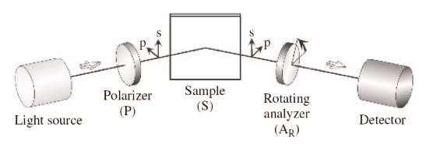

Setup mainly consist of six components:

**The light source** which emits circularly or unpolarized light. This can be either a laser or some type of lamp. A laser has the advantage of emitting very intense and well collimated light which produces a very small spot size on the sample. It is however not possible to use a laser to perform spectroscopic measurements as the laser contains

only one wavelength. However a lamp made of e.g. Xenon emits light at many different wavelengths enabling spectroscopic measurement.

**The linear polarizer** which converts the incoming light to linearly polarized light. The rotational azimuth angle of the polarizer relative to the direction of the   linear Eigen polarization is denoted *P* in the figure. This angle is the angle from the plane of incidence to the transmission axis of the polarizer.

**The compensator** or linear retarder, retards the two perpendicular components of the electrical vector by different amounts thus alternating the polarization state of the wave. The azimuth angle of the compensator *C* is measured relative to the direction of the

❐ Eigen polarization.

**The surface** where a fraction of the light wave is transmitted and another is reflected due to the Fresnel reflection and transmission coefficients , ,  and  .

**The analyzer** is a linear polarizer at a rotational azimuth angle αArelative to the π direction of the linear eigen polarization.

**The detector** measures the intensity of the light from the analyzer. The detector can be any device able to measure the intensity of a light wave.

**Specimen Geometry:-**

Silicon dioxide film whose thickness (d) we want to measure is sandwiched between two cylindrical substrate. The whole assembly looks like the figure below.

The inner details of this specimen is given below.

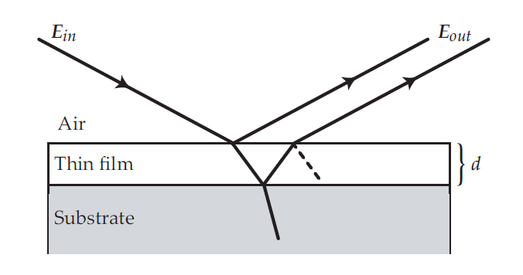

We have to measure d.

**Procedure:-**

1. Put analyzer, polarizer and quarter wave plate to null position.

2. Switch on the laser.

3. Rotate analyzer and remove the bright spot present, take down the initial reading of analyzer (This step is just for setting of quarter wave plate).

4. Now move the quarter wave plate and set for null condition.

5. Note down the angle of quarter wave plate and rotate it by adding 45 degree to initial reading for getting bright spot.

6. Move both arms up by 20 degree rotation.

7. Now put the sample (Hold the sample from marked side and put the unmarked side up).

8. Rotate analyzer and polarizer both simultaneously in 0 to 90 degree.

9. This gives the reading P1 and A1 for polarizer and analyzer respectively.

P2=P1+90

10. Set P2 and rotate the analyzer to get A2.

11. Provide the values of P1, A1 and P2, A2 on software available and calculatethe thickness of the sample.

**Observations and Results:**

1. **First observation**

|  |  |
| --- | --- |
| Quantity | Angle (Degrees) |
| P1 | 40.5 |
| A1 | 235.0 |
| P2 | 130.1 |
| A2 | 156.4 |

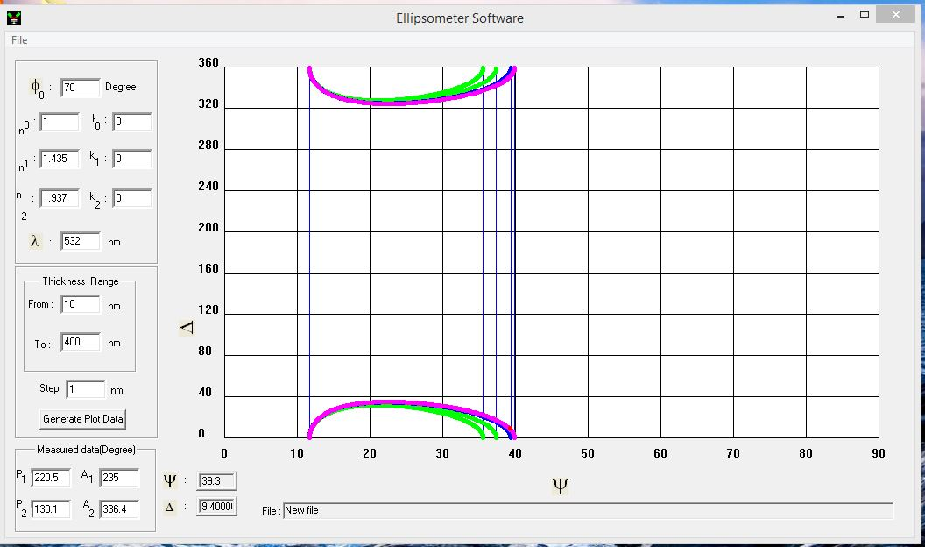

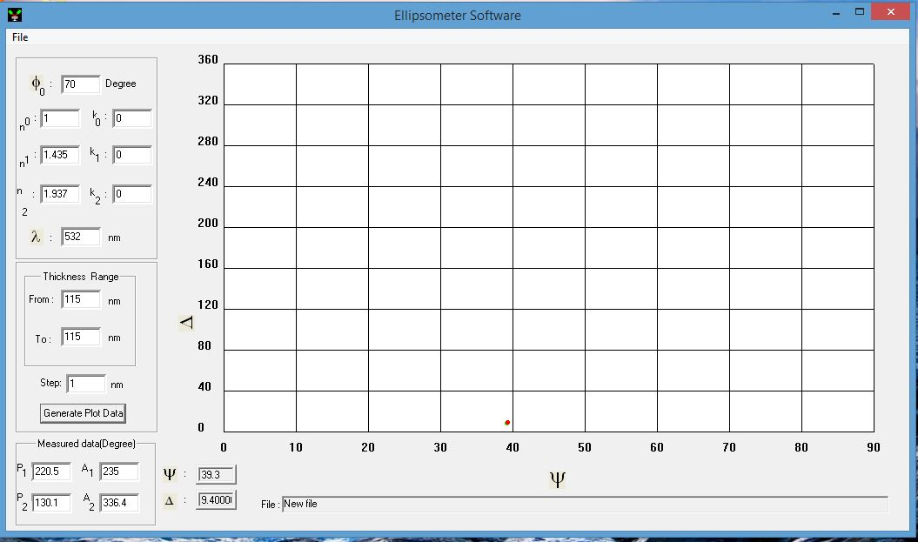

Thickness: 115 nm

Refractive Index: 1.435

**2. Second observation**

|  |  |
| --- | --- |
| Quantity | Angle (Degrees) |
| P1 | 30.9 |
| A1 | 44.5 |
| P2 | 120.9 |
| A2 | 164.8 |

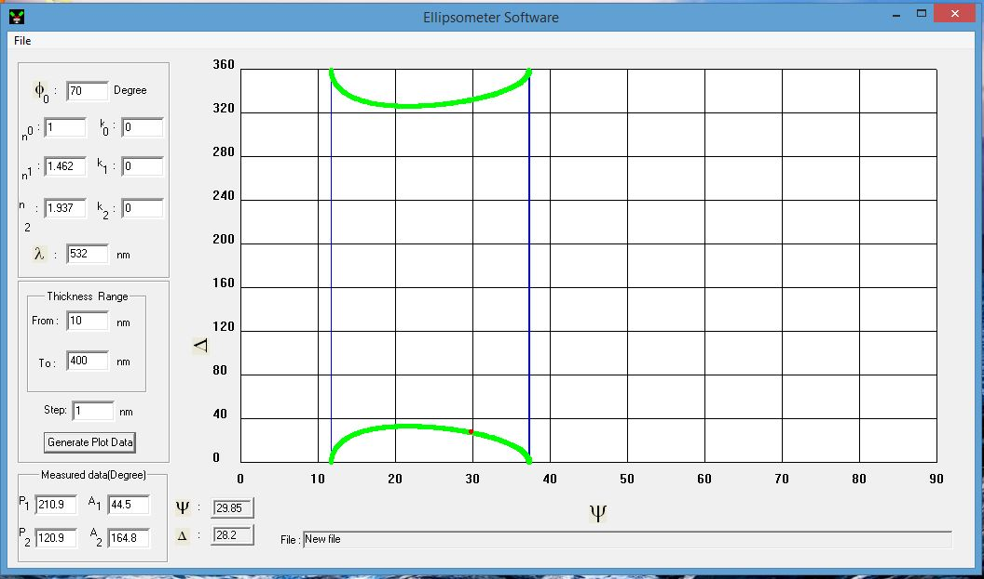

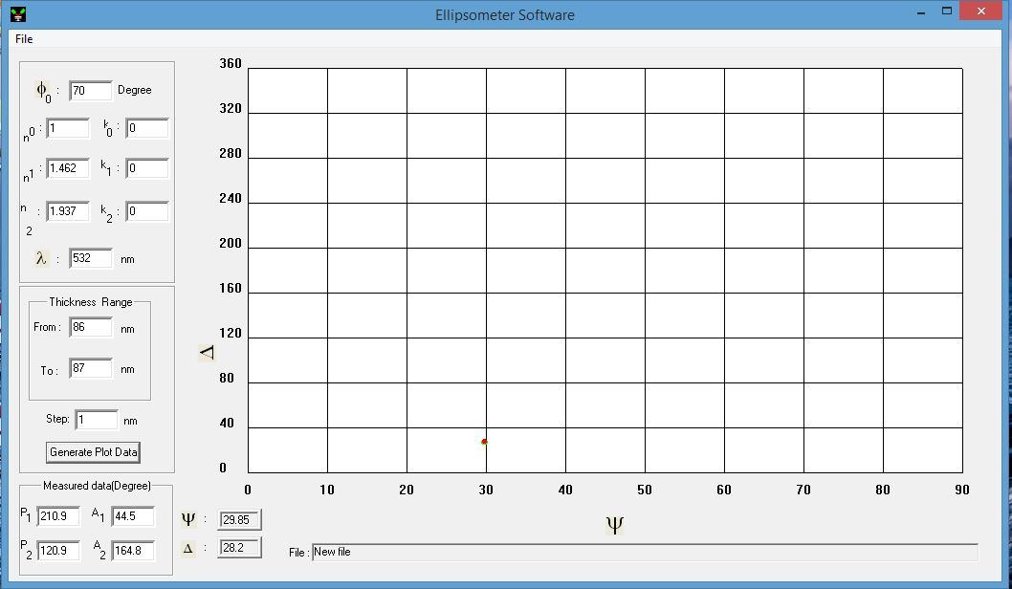

Thickness: 87 nm

Refractive Index: 1.462

1. **Third Observation**

|  |  |
| --- | --- |
| Quantity | Angle (Degrees) |
| P1 | 59 |
| A1 | 43.5 |
| P2 | 148.5 |
| A2 | 168.5 |

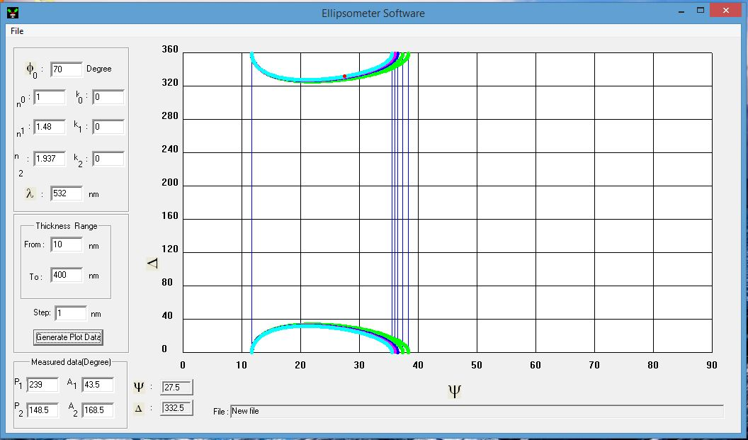

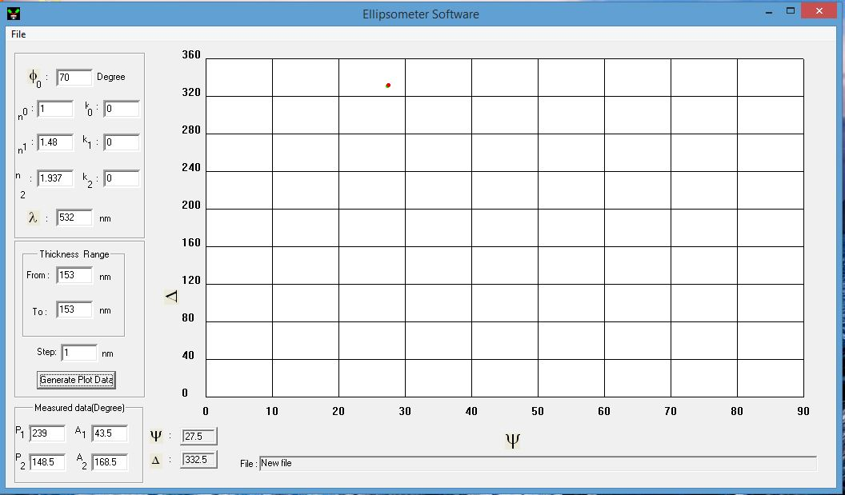

Thickness: 153 nm

Refractive Index: 1.48

Average Refractive Index = (1.435 + 1.462 + 1.48) / 3

= 1.459

**Discussion:**

The plots shown above are plotted using a software meant to measure thickness using ellipsometry. They give us the relation between phase shift angle and total reflection ratio coefficients.

Graphs are plotted by using the formula

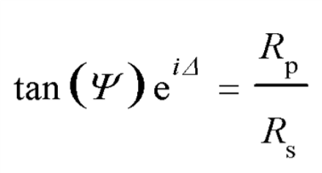

where

Δ=Phase shift angle, Relative Phase retardation

Ψ=Magnitude Ratio of Total Reflection Coefficients

Rp, Rs = Reflection Coefficients

Rp/Rs = Complex Reflectance ratio

Using the software we estimate the thickness of the film by reducing the range of thickness till the green curve overlaps with the red dot indicating the thickness of the film.

**Conclusion:**

The average thickness of the given sample of SiO2 is between 87 nm to 153 nm and refractive index is 1.439.

**Precautions:**

* Don’t look into the laser beam and don’t wear reflective stuff like watches or rings.
* When working on the sample table, keep the laser lid shut.
* Don’t touch the film with your fingers.
* Clean specimen before using it.

**References:**

* William D. Callister, Jr., and David G. Rethwisch, Material Science and Engineering an Introduction, 8th Ed.
* Fundamentals of material science and engineering by William D. Callister, Jr. 4th edition.
* Wikipedia
* Previous Year Lab Manual